Emergency Management Plans

(3) LOCAL RECOVERY PLAN
2019

Associated Set of Plans
- Emergency Management Strategic Plan 2017 - 2021
- General Plan 2019
- Local Recovery Plan 2019
- Local Welfare Plan 2017 (Restricted)

To be read in conjunction with
- City of Perth Strategic Community Plan
- Business Continuity Plan
Contents
Associated Set of Plans 1
To be read in conjunction with 1
Distribution List 4
Amendment Record 5
Acronyms 6
Part 1 Introduction 7
1.1 Overview 7
1.1.1 Authority 7
1.1.2 Community Consultation 7
1.1.3 Aim 7
1.1.4 Objectives 7
1.1.5 Purpose 7
1.1.6 Scope 7
1.1.7 Related Documents and Plans 7
1.1.8 Agreements, Understandings and Commitments 8
1.1.9 Activation of the Local Recovery Plan (LRP) 8
Part 2 Recovery 9
2.1 Overview 9
2.1.1 National Principles for Disaster Recovery 9
Part 3 Key Tasks, Roles and Responsibilities 10
3.1 Impact Assessment 10
3.1.1 Comprehensive Impact Assessment 10
3.1.2 Outreach Needs Assessment 10
3.1.3 Data Management 10
3.1.4 Recovery Coordination Centre 11
3.1.5 One Stop Shop 11
3.2 Community Involvement 12
3.2.1 Participation in the Local Recovery Coordinating Group (LRCG) 12
3.2.2 Strategic Long-Term Recovery Plan 12
3.2.3 Managed Withdrawal 12
3.3 Management of Donations 12
3.3.1 Donation Management 12
3.3.2 Spontaneous Volunteers 12
3.3.3 Lord Mayors Distress Relief Fund (LMDRF) 13
3.3.4 Financial Donations 13
3.4 Business Management Arrangements 14
3.4.1 Financial Management 14
3.5 State Government Involvement 15
3.5.1 State Recovery Coordinator (SRC) 15
3.5.2 State Recovery Coordination Group (SRCG) 15
3.5.3 State Recovery Controller 16
3.5.4 Reporting 16
3.6 Public Information 16
3.6.1 Spokespersons 16
3.6.2 Recovery Communications Plan 16
Part 4 Operational Recovery Planning 17
4.1 Recovery Management Structure 17
4.1.1 Local Recovery Coordinator (LRC) 17
4.1.2 Local Recovery Coordination Group (LRCG) 17
4.1.3 Sub-committee structure 18
4.1.4 Subcommittee Terms of Reference 19
4.1.5 Organisational Responsibilities 19
4.1.6 Recovery Operational Checklist 20
4.2 Operational Recovery Plan 20
4.2.1 Template 20
4.3 Service Delivery Transition 20
4.3.1 Welfare Support / Debrief 20
4.3.2 Evaluation 20
Appendix 1 Outreach Needs Assessment form example 21
Appendix 2 Donation Management Media Statement example 22
Appendix 3 Operational Recovery Plan template 23
Section 1 Introduction 23
Section 2 Assessment of Recovery Requirements 23
Section 3 Organisational Aspects 23
Section 4 Operational Aspects 23
Section 5 Administrative Arrangements 23
Section 6 Long Term Recovery Arrangements 24
Section 7 Conclusion 24
Appendix 4 Local Recovery Coordinator (LRC) Start-Up Checklist 25
Appendix 5 Recovery Operational Checklist 26
Appendix 6 Local Recovery Coordinating Group Sub-Committee Terms of Reference example 28
Authority 28
Aim 28
Purpose 28
Reporting 28
Social Sub-committee 28
Environment Sub-committee 29
Built Sub-committee 29
Economic Sub-committee 29
Appendix 7 Local Recovery Coordination Group (LRCG) Organisational Responsibilities 30

Distribution and availability
Document is sent to the City of Perth LEMC members via the email distribution list. It is also available via the City’s eMerge portal.
A copy is available at the City of Perth library and council offices.

Amendment Record
Amendment |  | Amendment Summary | Amended by
No. | Date
1 | August 2017 | Complete reissue | Jane Hannaford
2 | February 2019 | Reformat and review content | Dean Ball
3 | June 2019 | LEMC Endorsed and plan finalised | Dean Ball
4 | June 2020 | Contacts and COP role review | Dean Ball
5
6
7

Acronyms
General acronyms that are used in the City of Perth Local Recovery Plan.
Short Name | Full Name
AIIMS | Australasian Inter-Service Incident Management System
BGPA | Botanic Gardens and Parks Authority
BOM | Bureau of Meteorology
CA | Controlling Agency
CEO | Chief Executive Officer
COP | City of Perth
DC | Department of Communities
DEMC | District Emergency Management Committee
DFES | Department of Fire and Emergency Services
DOT | Department of Transport
ECC | Emergency Coordination Centre
EM | Emergency Management
EMA | Emergency Management Agency
EMP | Emergency Management Plan
ERM | Emergency Risk Management
HMA | Hazard Management Agency
HVM | Hostile Vehicle Mitigation
ISG | Incident Support Group
LEC | Local Emergency Coordinator
LEMC | Local Emergency Management Committee
LG | Local Government
LMDRF | Lord Mayors Distress Relief Fund
LRC | Local Recovery Coordinator
LRCG | Local Recovery Coordinating Group
LRP | Local Recovery Plan
NGO | Non-Government Organisation
OAM | Operations Area Manager
OASG | Operations Area Support Group
PPRR | Prevention, Preparedness, Response and Recovery
SO | Support Organisation
SECG | State Emergency Coordination Group
SEMC | State Emergency Management Committee
SEWS | Standard Emergency Warning Signal
WAPOL | Western Australian Police Force

Part 1 Introduction

1.1 Overview
The Introduction provides brief details of the essential components for the COP Emergency Management Local Recovery Plan.

1.1.1 Authority
The set of COP Emergency Management Plans have been prepared in accordance with section 41(1) of the Emergency Management Act 2005. They have been endorsed by the COP and the COP LEMC.

1.1.2 Community Consultation
In the development of the LRP, the COP consulted with key stakeholders relevant to emergency management

1.1.3 Aim
The aim of the COP LRP is to document and facilitate community or LG recovery from an emergency in the COP LG district.

1.1.4 Objectives
The objectives of the COP LRP are to:
- Identify and coordinate effective process to facilitate community recovery;
- Ensure community participation in the recovery process by providing recovery management structures; and
- Identify activation triggers for the COP LRP.

1.1.5 Purpose
The purpose of this plan is to facilitate the recovery of individuals, the community and the COP LG from an emergency.

1.1.6 Scope
This document applies to the COP LG district, detailing the COP capacity to provide support to the community in its recovery from an emergency.

This document and associated set of plans have been written to ensure the COP is prepared to deal with identified emergencies within its LG district.

1.1.7 Related Documents and Plans
The COP EMP is a set of documents that can be used separately and must be acknowledged that they form part of a set of documents. These include:
- Emergency Management Strategic Plan 2017 – 2021;
- General Plan;
- Local Recovery Plan;
- Local Welfare Plan (developed by Department of Communities)
- Animal Welfare Plan
- Perth CBD Major Emergency Management Arrangements – Management of People Plan and
- Emergency Risk Management Plan

1.1.8 Agreements, Understandings and Commitments
The LRP forms part of the COP’s Emergency Management Strategic Plan 2017 – 2021.
Memorandums of Understanding have been developed with privately owned centres that were identified as possible Welfare Centre locations.

1.1.9 Activation of the Local Recovery Plan (LRP)
In consultation with the HMA, the COP LRC will arrange for the activation of this COP LRP.

Part 2 Recovery

2.1 Overview
LG’s are the communities closest form of government and are best placed to provide them specialist knowledge and support during and following an emergency event. The COP LG have well developed community links, support mechanisms, knowledge of the local environment and the demographic features of their communities.
LG can assist the HMA on matters related to their LG area by providing advice and resources to manage an emergency. LG’s lead, manage and coordinate community recovery at the local level and undertake these responsibilities in close cooperation with or directly supported by State government departments and other support agencies.
Section 36(b) of the Emergency Management Act 2005 (EM Act), ‘It is a function of local government…to manage recovery following an emergency.’
The COP recognises that, under certain circumstances, response and recovery may occur simultaneously.

2.1.1 National Principles for Disaster Recovery
The national principles for disaster recovery state that ‘Disaster Recovery’ or ‘Emergency Recovery’ in Western Australia forms part of emergency management, this includes the broader components of prevention, preparedness and response.

To ensure that all aspects of emergency recovery are considered, recovery arrangements should acknowledge that successful recovery relies on:
- Understanding the context;
- Recognising the complexity;
- Using community-led approaches;
- Ensuring coordination of all activities;
- Employing effective communications; and
- Acknowledging and building capacity.

Part 3 Key Tasks, Roles and Responsibilities
To ensure that recovery priorities are managed, key planning tasks, roles and responsibilities will be considered under relevant categories.

3.1 Impact Assessment
Impact assessment involves gaining early and accurate information about the impact of the emergency on individuals, the community and infrastructure. Impact assessment information received from the HMA is essential to manage an effective recovery program.

The COP will be proactive in identifying the need for the activation of the recovery process.

3.1.1 Comprehensive Impact Assessment
In consultation with the ISG, the HMA will complete the ‘Comprehensive Impact Assessment’. This assessment contains a detailed description of the impact to affected communities and provides the LRC with a starting point for recovery needs.

3.1.2 Outreach Needs Assessment
When a community is affected by an emergency it is essential to determine the needs of the community as these needs are often significant and varied. One of the best ways to capture this information is using a technique called “Outreach” whereby volunteers from the Australian Red Cross and other agencies partner with the LG to speak directly to impacted individuals. This will determine what and who has been affected, what information is needed, what assistance is required, if they wish to be contacted for further information and their best contact details.

Consideration will be given by the COP through the LRCG sub-committee to determine recovery needs of the affected community. The Australian Red Cross can provide support for the COP in undertaking an immediate needs assessment via “Outreach”.

Consideration of the needs and impact on residents, businesses, visitors, workers, government and tourists will also be included as part of this process.

A sample Outreach Needs Assessment form can be found at Appendix 1 – Outreach Needs Assessment Form Example.

3.1.3 Data Management
Information gathered in the recovery process will be managed in collaboration with the Red Cross via the Red Cross database and the COP eMERGE portal. This will capture data for:
- Individuals affected;
- Properties affected; and
- Outreach Impact Assessment.

3.1.4 Recovery Coordination Centre
The COP Recovery Coordination Centre location for LRCG meetings and key COP staff involved in recovery will be located as per arrangements or by the LRC.

Name | Location
Level 7, Council House | 27 St Georges Tce, Perth
CityWatch | East Perth

3.1.5 One Stop Shop
The community One Stop Shop with all relevant member agencies and the COP key staff to engage and assist the community in recovery will be located at:

Name | Location
Perth Town Hall | Cnr Barrack & Hay St, Perth
City Place Community Centre | Railway Concourse, Wellington St  Perth
City of Perth Library | Hay St Perth
COP Customer Service | Ground Floor & Level 5 Contact Centre  Council House

3.2 Community Involvement
Communities threatened or impacted by an emergency need to be actively involved in their own recovery. This means establishing the four key areas for community services and activity in recovery including the economic, social, environment and built environments.

3.2.1 Participation in the Local Recovery Coordinating Group (LRCG)
For each of the relevant LRCG sub-committees, community representation and key stakeholders will be a considered for inclusion dependant on the nature and impact of the emergency.

3.2.2 Strategic Long-Term Recovery Plan
In addition to building resilience to future emergencies, a strategic long-term recovery plan is developed to achieve holistic, long-term, enduring recovery for those impacted by an emergency. Where appropriate, the COP will develop a collaborative, comprehensive and inclusive long-term community recovery strategy for the community.

3.2.3 Managed Withdrawal
The COP will communicate via the LRCG sub-committees when relevant service providers and agencies will be withdrawing services from the affected area.

3.3 Management of Donations
One of the big impacts for the LG following an emergency is the generous public donation of goods. When they see suffering, people are drawn to help and one way they show this support is by donating physical goods. As the LG now must manage the storage and distribution of these goods, this can prove to be an unexpected workload.

As such, the COP will not accept the donation of goods. Our preference is to encourage the public to look at selling the goods privately and donating the money to the recovery organisations.

3.3.1 Donation Management
In all media statements, a COP spokesperson will reinforce that the donation of goods, although appreciated, is not needed and cannot be accepted. A sample media statement about donated goods is located at Appendix 4 – Donation Management Media Statement example.

3.3.2 Spontaneous Volunteers
Spontaneous volunteers may present to the COP to provide support and assistance to the affected community. In the first instance, the LCRG will determine the process to deal with these volunteers and what support agencies are required to assist further.

3.3.3 Lord Mayors Distress Relief Fund (LMDRF)
Depending on the nature of the emergency, to facilitate financial donations to individuals and families affected by the emergency, the State may activate the LMDRF. The LRC with the LRCG, will liaise with the LMDRF in terms of managing this process.
The LMDRF is managed at the COP by the Community Services Unit.

3.3.4 Financial Donations
Agencies, community groups and organisations that wish to make financial donations to COP communities or the LG will be directed to the COP LRCG to make appropriate arrangements.

3.4 Business Management Arrangements
It is essential to ensuring the COP continues to function whilst an emergency is occurring and during the recovery process. Financial, critical incident and business continuity arrangements should be enacted to ensure the COP can function on a day to day basis whilst managing the recovery process.

Business Continuity Plans can be found through eMERGE.

3.4.1 Financial Management
To provide financial relief to the COP in the community recovery process, application can be made through the Western Australian Natural Disaster Relief and Recovery Arrangements (WANDRRA). This is administered by the Office of Emergency Management (OEM), with assistance from other agencies.

To assist with the recovery, WANDRRA financial assistance can be provided to LG’s, agencies and community members who have been affected by a natural emergency or a terrorist event. The COP will enact a designated internal cost code to record the financial outgoings for the emergency and subsequent recovery.

3.5 State Government Involvement
The State Government may provide support and assistance to the COP in the recovery process. The support mechanisms are outlined below and the structure is shown in Figure 1.
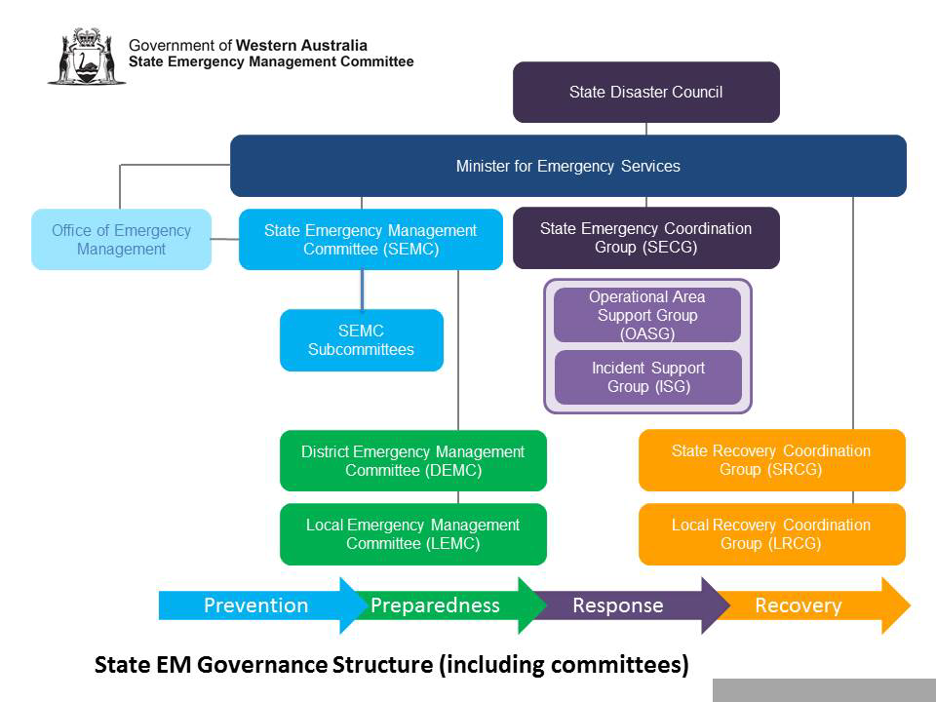
Figure 1: State Government involvement in recovery

3.5.1 State Recovery Coordinator (SRC)
The SEMC may appoint a SRC to support recovery activities for an emergency. The SRC coordinates a whole of government approach and the maintenance of the State recovery arrangements and plans through the SEMC recovery subcommittee and in partnership with the SEMC Secretariat.

If one has been established, the SRC supports the operation of State-level recovery coordination. In conjunction with the COP and the State Emergency Coordinator, the coordinator must consider the level of State involvement required and whether the SRCG and SRC should be established.

3.5.2 State Recovery Coordination Group (SRCG)
On their own initiative or on the advice and direction of the SECG, a SRCG is established by the SRC. When established, the SRCG is responsible for State level recovery coordination in complex or prolonged recovery operations.
The SRCG reports to the Minister and the Premier. Unless a State Recovery Controller has been appointed, the SRC will chair the SRCG.

When a State-level operational recovery plan is developed by the SRCG, an evaluation of its effectiveness must be conducted after the State-level recovery coordination arrangements.

3.5.3 State Recovery Controller
The State Recovery Controller is appointed by the Premier, on the recommendation of the SRC and in consultation with the State Emergency Coordinator.

The appointment of the State Recovery Controller will usually occur when an emergency affects several communities, is ongoing, requires State level assistance to resolve issues and needs a regional coordination approach.

3.5.4 Reporting
Should the level of recovery warrant assistance from the state, the SRC or the State Recovery Controller will liaise with the COP LRC.

Regular verbal and written reports may be required by the LRC from the above-mentioned positions. An Operational Recovery Plan can provide the essential reporting elements to the SRC or Controller.

A copy of an Operational Recovery Plan template can be found at Appendix 5– Operational Recovery Plan template.

3.6 Public Information
Recovery communications is the practice of sending, gathering, managing and evaluating information. A well planned and executed public information plan is vital in recovery.

3.6.1 Spokespersons
The spokespersons for the COP during a recovery will be the Lord Mayor, Chief Executive Officer or their delegate.

3.6.2 Recovery Communications Plan
A Recovery Communications Plan will be developed at the COP by the Director Economic Development & Activation. It will be provided to the LRCG and detail a vision and mission for communication to the affected community.

Part 4 Operational Recovery Planning

4.1 Recovery Management Structure
A management structure is required to achieve all the activities required and undertake responsibilities in recovery. To ensure that all priorities are targeted, key planning tasks, roles and responsibilities will be considered under relevant categories.

4.1.1 Local Recovery Coordinator (LRC)
The LRC is responsible for the development and implementation of recovery management arrangements for the COP. The nominated COP LRC is the Director, Community & Commercial Services. The LRC is supported by the Manager, Community Amenity and Safety.

When considered appropriate for community recovery, the LRC determines the establishment of a LRCG and is chair of this group. When formed, the LRC coordinates local-level recovery activities in conjunction with the LRCG, and in accordance with the determined plans, strategies and policies.

A start-up checklist for the LRC can be found at Appendix 4 – Local Recovery Coordinator Start-Up Checklist.

4.1.2 Local Recovery Coordination Group (LRCG)
A LRCG is the strategic decision-making body for recovery. The LRCG provide visible and strong leadership and have a key role in restoring confidence back into the community.

Relative to the incident and identified by the LRC, the LCRG will consist of appropriate COP directors, managers and staff. It can also include elected members, community representatives, people from supporting state agencies and organisations, and people from local organisations.

The structure for a large-scale emergency for the COP is listed below including key positions:

Key Position | Name
Chairperson / LRC | GM Community Development Alliance
Alternate Local Recovery Coordinator | GM Infrastructure and Operations Alliance
Spokesperson | Chair Commissioner / Lord Mayor
Communications Officer | Snr Media Adviser
Social Sub-Committee Chair | Alliance Manager Community Services
Environment Sub-Committee Chair | Alliance Manager Operations
Economic Sub-Committee Chair | Alliance Manager Economic Development
Built Environment Sub-Committee Chair | Alliance Manager Infrastructure and Assets
LRC Support | Alliance Manager Community Safety and Amenity
LRCG | Coordinator Community Safety

A recovery operational checklist for the LRCG can be found at Appendix 5 - Recovery Operational Checklist.

4.1.3 Sub-committee structure
Current Australian best practice in recovery suggests utilising sub-committee structures to support the community recovery activities. Depending on the scale of the emergency, sub-committees should be formed with specified responsibilities each reporting to the LRCG.

Details of the suggested sub-committee structure for the COP and key member agencies that may assist in recovery have been listed below.

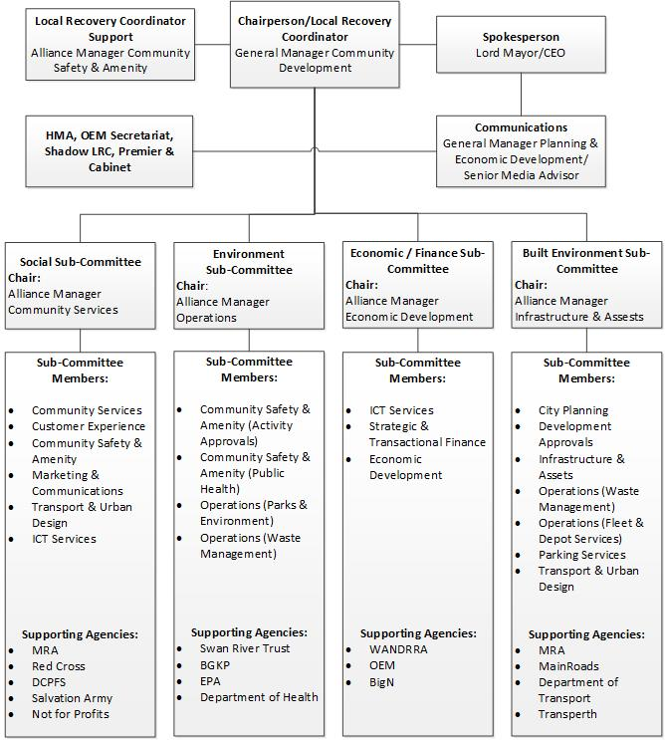

4.1.4 Subcommittee Terms of Reference
The LRCG and relevant subcommittees may change over time. LRCG sub-committees require assistance and guidance to operate in a highly stressful and time poor environment. Terms of reference for LRCG sub-committees’ will assist with the management of short, medium and long-term recovery.

A template Subcommittee Terms of Reference is located at Appendix 6 - Local Recovery Coordinating Group Sub-Committee Terms of Reference Example.

4.1.5 Organisational Responsibilities
The key member agencies listed within the LRCG and sub-committee structure will have specified responsibilities to assist the COP in recovery.

An appendix of the suggested organisational responsibilities is located at Appendix 7 - Local Recovery Coordination Group Organisational Responsibilities Example.

4.1.6 Recovery Operational Checklist
A checklist to assist the LRC and the COP with recovery services and activities within the community is located at Appendix 5 – Recovery Operational Checklist.

4.2 Operational Recovery Plan
The operational recovery plan provides a full description of the extent of harm or damage and detailed plans for restoration and reconstruction of the affected community. This will be prepared by the LRC with assistance from the LRCG.

4.2.1 Template
A template for an Operational Recovery Plan with key headings is located at Appendix 3 – Operational Recovery Plan template.

4.3 Service Delivery Transition
There is no definite end period to recovery; however, consideration is required to determine when the COP will resume normal service delivery. This decision will be made depending on the severity and nature of the emergency, and the residual impact on the COP and the community.

4.3.1 Welfare Support / Debrief
Welfare support will be ongoing throughout the recovery period. As COP staff transition from recovery back to their normal duties, formal debriefing arrangement will be instigated by the Manager Human Resources through the Employee Assistance Program.

4.3.2 Evaluation
The one-year anniversary for the emergency marks the time when the LG is required under state emergency management guidelines to provide an evaluation report for recovery activities.

On behalf of the COP, the LRC will provide the SRC a formal report about the recovery process.

Appendix 1 Outreach Needs Assessment form example
Date: ___________________ TEAM No: ________
Hello my name is ______________________________and I am from local government/Red Cross on behalf of the City of Perth.
We are here to (engage/speak/check in) with rural land-owners to see how best we can assist you following the emergency.
We’re collecting a database of affected people and impact on properties to ensure we deliver up-to-date information and assistance in connecting people with appropriate organisations/agencies/people depending on assistance you may require.
PROPERTY DETAILS
Location (Lot No/Apartment, Street name, Area):
 |  |  | Nearest Cross Road:
Property Owner/ Occupant Name:
How would you like to be contacted? |  |  |  | Your preferred time?
Phone: |  |  |  |  | Morning (7am – 12noon)
Email: |  |  |  |  | Afternoon (12noon – 5pm)
Post: |  |  |  |  | Evening (After 5pm)
PROPERTY NEEDS Please provide information on detail for any needs identified
 | House/Apartment Destroyed/ Uninhabitable
 | House/Apartment Damaged
 | Outbuildings destroyed Total: _______
 | Rebuilding Assistance
 | Asbestos/ Possible asbestos
 | Water supply affected
 | Utility services affected
 | Fencing destroyed/ Damaged
 | Garden destroyed/ Damaged
 | Environmental clean-up required
 | Domestic animals lost/ Injured
 | Other (Please provide details) ____________________________
INFORMATION NEEDS |  |  |  | OTHER ASSITANCE REQUIRED
 | Rubbish collection/ Disposal Information |  |  |  | Council Services TYPE: ___________________
 | Recovery Information/ Newsletter |  |  |  | Referral to Agency WHO: _________________
 | Financial/ Grant assistance |  |  |  | Other (provide details):
 | Counselling/ Wellbeing Check
Would you like someone to contact you?
Immediately Within the week In the future (Box)
Source: Adapted from the Shire of Harvey Rural Outreach and Impact Assessment Form 2016.

Appendix 2 Donation Management Media Statement example

Recovery of the community after an emergency is the job of local government. The City of Perth is keen to ensure the community gets back on its’ feet following this emergency.

Western Australians are always extremely generous with their donations after a fire, flood or cyclone, however money donations are the best way to provide help for people in emergencies. Money donations provide the affected community with the ability to make choices for what they need and it also helps to support local businesses who benefit when we shop local.

The donation of any physical goods for our community is not needed. Should we need specific items, this need will be broadcast in the media. Those wishing to donate specific items that have requested should register their interest with local welfare agencies or agencies calling for such items.

Physical goods donated in an emergency, cause a huge stress and burden on local government and charities.

The best way to assist those in need is through your generous donation of money through the Lord Mayor’s Distress Relief Fund of WA. Listen out for where you can donate.

Thank you for your generous support.

Appendix 3 Operational Recovery Plan template

Section 1 Introduction
- Background on the nature of the emergency.
- Aim of the plan.
- Authority for plan.

Section 2 Assessment of Recovery Requirements
- Details of loss and damage to residential, commercial and industrial buildings, transport, essential services (including state and local government infrastructure).
- Estimated of cost of damage.
- Temporary accommodation requirements (includes details of evacuation centres).
- Additional personnel requirements (general and specialist).
- Human service (personal and psychiatric support) requirements.
- Other health issues.

Section 3 Organisational Aspects
- Details the composition, structure and reporting lines of the Local Recovery Coordinating Group (LRCG) and subcommittees set up to manage recovery.
- Details of the inter-agency relationships and responsibilities.
- Details of the roles, tasks and responsibilities of the LRCG, sub-committees and those appointed to positions including Local Recovery Coordinator.
- Communications plan.

Section 4 Operational Aspects
- Details resources available and required.
- Redevelopment plans (includes mitigation proposals).
- Reconstruction restoration programme and priorities, (including estimated timeframes).
- Includes programs and strategies for government agencies to restore essential services and policies for mitigation against future emergencies.
- Includes the local government program for community services restoration.
- Financial arrangements (assistance programs such as WANDRRA, insurance, public appeals and donations (see also Section 5 below).
- Public information dissemination.

Section 5 Administrative Arrangements
- Administration of recovery funding and other general financial issues.
- Public appeals policy and administration (including policies and strategies for office and living accommodation, furniture and equipment details for additional temporary personnel).

Section 6 Long Term Recovery Arrangements
- Plan.
- Positions.

Section 7 Conclusion
Summarises goals, priorities and timetable of the plan.

Signed by

_______________________________________

Chair
Local Recovery Coordination Group (LRCG)

Date:

Source: Adapted from the Shire of Harvey Operational Recovery Plan 2016.

Appendix 4 Local Recovery Coordinator (LRC) Start-Up Checklist

Action Description | Complete
Alert and contact key City of Perth (COP) Local Recovery Coordinating Group (LRCG) members (see Local Recovery Plan)
Contact key COP recovery contacts including the Chief Executive Officer (CEO) and Mayor (see Local Recovery Plan)
Ensure liaison with Incident Controller and attendance at Incident Support Group (ISG) meeting. If LRC cannot attend, ensure COP representative does attend.
LRC to determine if LRCG to meet once briefing received from Incident Controller or attendance at ISG
LRC in conjunction with the COP to receive Comprehensive Impact Assessment Form from the Hazard Management Agency and the handover formalisation of recovery occurs
Once decision on LRCG to meet, decide on initial membership, convene meeting and ensure administration support in place
In accordance with the Local Recovery Plan ensure all processes have commenced for the recovery process with the City of Perth
LRC to contact COP media spokesperson and provide briefing
LRC to consider internal support within the COP through the Critical Incident Management Plan activation by speaking with Critical Incident Management Controller
LRC to advise State Recovery Coordinator that Local Recovery Plan has been enacted
LRC to determine if Recovery Coordination Centre is required for the COP and activate where appropriate
LRC to determine if One Stop Shop is required and activate where appropriate
LRC to convene meeting of LRCG using an appropriate Chair to convene LRCG
LRC in conjunction with LRCG to determine the sub-committees required for this recovery (refer to Local Recovery Plan)
Commence development of an Operational Recovery Plan for the event
Confirm with COP Finance Manager that costs are currently being tracked for the event to determine whether the Western Australian Disaster Relief and Recovery Arrangements (WANDRRA) will be enacted
Ensure COP staff are briefed on their roles in recovery and information to advise calls from the public
Consider the establishment of a call centre to assist with the enquiries from the COP community and the public
Ensure the state contact for GIVIT has been contacted so that offers of assistance and goods can be managed effectively

Appendix 5 Recovery Operational Checklist

Recovery Strategy | Commenced
Immediate/Short Term
Ensure energy and communication supplies are adequate and stable
Ensure and facilitate the completion of the immediate impact assessment
Establish strong relationships with key regional government agency representatives and appoint them to relevant sub-committees
Facilitate the provision of access to emergency funding
Gather evidence to support requests for government assistance
Establish a network for information provision to community
Assist with the support of animal welfare needs
Appoint a spokesperson from the City of Perth to deal with the media
Work within existing community organisations in the community
Assume public information responsibilities from the Hazard Management Agency and provide information to the community and the media
Create templates for impact assessment and for tracking assistance provided
Establish a system for recording all expenditure during recovery
Provide a one stop shop for advice, information and assistance to community
Identification and support to businesses and employers
Dissuade spontaneous donations of goods through Local Governments spokesperson
Provide psychosocial support
Facilitate and advise on State and Australian government funding
Conduct outreach program to community
Assist and liaise with businesses to re-establish and open
Re-establishment of transport needs
Develop a comprehensive media/community strategy
Provide assistance with insurance claims
Establish communications for planned recovery strategies to the community

Recovery Strategy | Commenced
Medium/Long Term
Assist with the redevelopment of social networks and connections
Support the community activities for the rescue and rehabilitation of wildlife
Support the restoration of key natural habitat
Restore banking and other financial solutions
Recruit members of the community for recovery strategy planning
Management of appeal funding to the affected community
Facilitate the distribution of appeal funds
Consider a strategy for the recovery process after the containment of contaminants
Monitor and assist the rehabilitation of critical infrastructure
Monitor and assist the restoration of residential buildings
Support the restoration of the rural infrastructure network
Renegotiation of loans for businesses
Improvements to infrastructure and services during reinstatement
Prepare oral and written financial and non-financial reports and briefs
Adjust capital works and maintenance programs
Stage a public event of acknowledgement and community closure

Appendix 6 Local Recovery Coordinating Group Sub-Committee Terms of Reference example

Authority
The Social, Natural, Economic and Built Environment sub-committees of the LRCG will be established in recovery by the LRC and endorsed in conjunction with the COP CEO and Mayor.

Aim
The aim of each sub-committee will be to develop partnerships between the COP and organisations and agencies that become sub-committee members to provide recovery services and activities for the community affected by an emergency.

Purpose
The purpose of each sub-committee is to provide;
Recovery operational responsibilities
Local and state arrangements for recovery services
Advice on matters pertaining to subject matter expertise
Interagency cooperation on recovery service and activities
Efficient service provision between agencies and organisations
Resource capacities
Key agency and organisational contacts

Reporting
Each sub-committee will report their services and activities through their nominated Chair to the LRCG.

Social Setting Sub-committee
To provide advice and guidance to assist in the restoration and strengthening of the community well-being.
To facilitate understanding on the needs of the impacted community in relation to community wellbeing.
To assess and recommend priority areas, projects, and events to assist with the recovery process in the immediate and short-term regarding the restoration and strengthening of community wellbeing.
To assess and recommend medium and long-term priority areas to the LG for consideration to assist in the restoration and strengthening of community wellbeing.
To ensure the affected community is informed and involved in the recovery processes so actions and programs match their needs.

Environment Sub-committee
To provide advice and guidance to assist in the restoration of the natural environment.
To facilitate understanding of the needs of the impacted community in relation to environmental restoration.
To assess and recommend priority areas, projects and community education to assist with the recovery process in the immediate and short-term regarding the restoration of the environment including weed management and impacts on wildlife.
To assess and recommend medium and long-term priority areas to the COP for consideration to assist in the restoration of the natural environment in the medium to long term.

Built Sub-committee
Assist in assessing requirements for the restoration of services and facilities in conjunction with the responsible agencies.
To provide advice and assist in the coordination of the restoration of infrastructure assets and essential services damaged or destroyed.
To assess and recommend priority infrastructure projects to assist with the recovery process in the immediate and short, medium and long term for the COP.

Economic Sub-committee
To make recommendations to the LMDRF on the orderly and equitable disbursement of donations and offers of assistance to individuals having suffered personal loss and hardship.
Coordinate the development of eligibility criteria and procedures by which payments from the LMDRF will be made to affected individuals.
Coordinate and facilitate the disbursement of financial donations from the corporate sector to affected individuals, where practical.
Coordinate all recording activities for WANDRRA.

Source: Adapted from the City of Bunbury Emergency Management Arrangements and the State Emergency Management Local Recovery Guidelines 2016.

Appendix 7 Local Recovery Coordination Group (LRCG) Organisational Responsibilities

LRCG member role | Responsibilities
LRCG Chair | - Chair the COP LRCG.  - Establish sub-committees as required.  - Ensure key staffing roles within the COP are fulfilled including administration support to the LRC and the LRCG.  - Ensure the development of an Operational Recovery Plan.
LRC | - Liaise with the HMA and attend ISG or OASG meetings.  - Provide advice to the COP Mayor and the CEO on the requirement to convene a LRCG.  - Assess the community recovery requirements in conjunction with the LRCG.  - Liaise with the SRC.
LRCG Executive Officer | - Provide executive support to the LRCG.
LRCG Communications/Media Officer | - Provide media and communications support to the COP spokesperson.  - Provide media and communications support and advice to the LRCG.  - Ensure an internal and external communications plan has been established.
Community Representative (Affected Community) | - Provide liaison and consultation from the affected community  - Assist with the communications conduit to affected community
COP Street Presentation & Maintenance | - Maintain and coordinate the cleaning up of roads, drainage and footpaths.  - Provide advice and support to the LRCG.
COP Waste & Cleansing | - Coordinate and carry out waste collection and disposal including hard and green waste including normal waste collection.  - Provide advice and key contacts to the COP for extra ordinary waste removal such as asbestos.  - Provide advice and support to the LRCG.
COP Community Services | - Provide health and wellbeing support and programs to the communities of the COP.  - Provide advice and support to the LRCG.
COP Construction | - Maintain and coordinate the construction of roads, drainage and footpaths.
COP Plant & Equipment | - Maintain and coordinate plant and equipment for operations dedicated to recovery efforts.  - Provide advice and support to the LRCG.
COP Environmental & Public Health | - Develop, implement and coordinate environmental and public health programs to support recovery.  - Provide advice and support to the LRCG.
Department of Communities | - Coordinate all welfare arrangements for the COP as per the Local Welfare Plan.  - Provide advice and support to the LRCG.  - Provide funding options to the community through WANDRRA.
Centrelink | - Provide funding arrangements to support the community in recovery.  - Provide advice and support to the LRCG.
DFES | - Provide liaison, consultation advice and support to the LRCG
Department of Health | - Coordinate human disease control and other health issues.  - Provide advice and support to the LRCG.
Chamber of Commerce | - Provide liaison and consultation with the business community.  - Promote and support business and economic development strategies in recovery.  - Provide advice and support to the LRCG.
Red Cross | - Provide recovery advice to the LRCG.  - Assess community needs assessment requirements.  - Assess and provide outreach program in conjunction with the COP.  - Provide advice and support to the LRCG.
Department of Education and Training | - Provide liaison and consultation with schools in the COP.  - Provide advice and support to the LRCG.
Main Roads | - Provide liaison and consultation arrangements about the road network and infrastructure within the COP.  - Provide advice and support to the LRCG.

