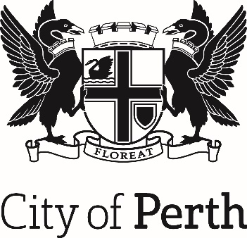

Emergency Management Plans

(2) GENERAL PLAN
2017

Associated Set of Plans
- Emergency Management Strategic Plan 2017 – 2021
- General Plan 2017
- Local Recovery Plan 2017
- Local Welfare Plan 2017 (Restricted)
- Animal Welfare Plan 2017

To be read in conjunction with
- City of Perth Strategic Community Plan
- Business Continuity Plan

City of Perth Emergency Management Plans

These plans are produced and issued for the City of Perth under section 41(1) of the Emergency Management Act 2005.

These plans have been endorsed by the City of Perth Local Emergency Management Committee and the City of Perth. The plans will be tabled for the District Emergency Management Committee and the State Emergency Management Committee Secretariat.

____________________________________ ___________________
Chairperson Date
City of Perth
Local Emergency Management Committee
Anne Banks-McAllister

Contents

Associated Set of Plans 1
City of Perth Emergency Management Plans 2
Emergency Management Plans 5
Emergency Management Aspirations 5
Distribution and availibility 6
Amendment Record 6
Glossary of Terms 7
Acronyms 10
Part 1 Introduction 11
1.1 Overview 11
1.1.1 Authority 11
1.1.2 Community Consultation 11
1.1.3 Aim 11
1.1.4 Purpose 11
1.1.5 Scope 11
1.1.6 Related Documents and Plans 12
1.1.7 Agreements, Understandings and Commitments 12
1.1.8 Resources 12
1.1.9 Financial Arrangements 12
1.1.10 Authority to Incur Expense by the COP 13
1.1.11 Review and Exercising 13
1.2 Community Profile 14
1.2.1 Special Considerations 14
1.2.2 Utilities and Access 14
1.2.3 Key Public Events 15
1.2.4 Cultural Considerations 15
Part 2 Planning 16
2.1 Local Emergency Management Committee 16
2.1.1 LEMC Functions 17
2.1.2 Chairperson and Deputy 17
2.1.3 Executive Officer 17
2.1.4 Committee Membership 18
2.1.5 LEMC Member Roles and Responsibilities 18
2.1.6 Meeting Schedule 18
2.1.7 Meeting Procedures and Agenda 19
2.2 Emergency Risk Management 20
2.2.1 Identified Hazards 20
Part 3 Response 21
3.1 Coordination of Emergency Operations 21
3.1.1 Local Emergency Coordinator (LEC) 21
3.1.2 Incident Support Group (ISG) 21
3.1.2.1 Triggers for a ISG 21
3.1.2.2 Membership of a ISG 21
3.1.2.3 Location of the ISG 22
3.1.3 Emergency Coordination Centre (ECC) 22
3.1.4 CityWatch 22
3.2 Media Management and Public Information 22
3.2.1 City of Perth Spokesperson 22
3.2.2 COP Communications 23
3.3 Evacuation 23
3.3.1 Evacuation Management 23
3.3.2 Evacuation Planning 23
3.4 Welfare 23
3.4.1 Welfare Management 23
3.4.2 Welfare Centres 24
3.4.3 Animal Welfare Plan 24
3.5 Business Continuity 24
3.5.1 Critical Incident Management Team (CIMT) 24
3.5.2 Crisis Management Team (CMT) 24
Part 4 Recovery 25
4.1 Local Recovery Plan 25
4.2 Local Recovery Coordinator (LRC) 25
4.3 Local Recovery Coordination Group (LRCG) 25
Appendix 1 26
LEMC Member Roles and Responsibilities 26

Emergency Management Plans

The City of Perth has produced a series of Emergency Management Plans to clearly identify roles and processes in the preparation, response and recovery from emergency situations within the City of Perth boundaries.

These plans are supporting documents for the City of Perth Emergency Management Strategic Plan 2017 - 2021 which encompasses the wider actions that will be undertaken to identify and manage risks and wherever possible, prevent issues arising.

The objectives and measures can be found in the Emergency Management Strategic Plan 2017 – 2021 and these will be reviewed annually as part of the work plan for the LEMC

Emergency Management Aspirations

Research - Sound research-based strategies, focus and outcomes.

Risk Management - Underpinning all practice with risk management principles.

Readiness - An organisation and community ready for emergencies.

Response -Timely internal and community response to emergencies.

Recovery - A city with an ability to recover from emergencies, internally and externally.

Distribution and availability

Document is sent to the City of Perth LEMC members via the email distribution list. It is also available via the City’s eMerge portal.
A copy is available at the City of Perth library and council offices.

Amendment Record

Amendment |  | Amendment Summary | Amended by
No. | Date
1 | August 2017 | Complete review and reissue | Jane Hannaford
2 | February 2019 | Complete review and reissue | Dean Ball
3 | June 2019 | LEMC Endorsed and plans finalised | Dean Ball
4 | December 2019 | Minor updates | Jane Hannaford
5 | May 2020 | Contacts updated | Dean Ball
6 | March 2022 | Minor updates | Jane Hannaford
7
8
9
10

Glossary of Terms

This is not a full glossary of terms for emergency management. Only those terms used for the General Plan are listed. For a full list of terms please refer to the State Emergency Management Glossary located at: www.semc.wa.gov.au

Terms | Meaning
Combat Agency | A combat agency prescribed under subsection (1) of the Emergency Management Act 2005 is to be a public authority or other person who or which, because of the agency’s functions under any written law or specialized knowledge, expertise and resources, is responsible for performing an emergency management activity prescribed by the regulations in relation to that agency.
Command | The direction of members and resources of an organisation in the performance of the organisation's role and tasks. Authority to command is established in legislation or by agreement with an organisation. Command relates to organisations and operates vertically within an organisation. See also control and coordination.
Control | The overall direction of emergency management activities in an emergency. Authority for control is established in legislation or in an emergency plan and carries with it the responsibility for tasking and coordinating other organisations in accordance with the needs of the situation. Control relates to situations and operates horizontally across organisations. See also command and coordination.
Control Centre | See emergency operations centre.
Controlling Agency | An agency nominated to control the response activities to a specified type of emergency.
Coordination | The bringing together of organisations and elements to ensure an effective response, primarily concerned with the systematic acquisition and application of resources (organisation, manpower and equipment) in accordance with the requirements imposed by the threat or impact of an emergency. Coordination relates primarily to resources, and operates, vertically, within an organisation, as a function of the authority to command, and horizontally, across organisations, as a function of the authority to control. See also control and command.
District Emergency Management Committee | A district emergency management committee established under section 31(1) of the Emergency Management Act 2005.
eMerge | City of Perth’s on-line emergency management portal.
Emergency | The occurrence or imminent occurrence of a hazard which is of such a nature or magnitude that it requires a significant and coordinated response (s.3 EM Act).
Emergency Coordination Centre | A facility established to coordinate and organize emergency provision of services. See also emergency operations centre.
Emergency Management | The management of the adverse effects of an emergency including:  - prevention – the mitigation or prevention of the probability of the occurrence of, and the potential adverse effects of, an emergency;  - preparedness – preparation for response to an emergency;  - response – the combating of the effects of an emergency, provision of emergency assistance for casualties, reduction of further damage, and help to speed recovery; and  - recovery – the support of emergency affected communities in the reconstruction and restoration of physical infrastructure, the environment and community, psychosocial and economic wellbeing.
Emergency Operations Centre | A facility, either static or mobile, from which the total operation or aspects of the operation are managed. A facility established to control and coordinate the response and support to an incident or emergency.
Emergency Risk Management | A systematic process which contributes to the wellbeing of communities and the environment. The process considers the likely effects of hazardous events and the controls by which they can be minimised.
Evacuation Centre | A centre that provides affected people with basic human needs including accommodation, food and water. In addition, to enhance the recovery process, other welfare/recovery services should also be provided.
Hazard | An event, situation or condition that can cause or resulting in loss of life, prejudice to the safety, or harm to the health of persons or animals; or destruction of, or damage to property or any part of the environment and is defined in the Emergency Management Act 2005 or prescribed in the Emergency Management Regulations 2006.
Hazard Management Agency | A public authority, or other person, prescribed by the Emergency Management Regulations 2006 to be a hazard management agency for emergency management, or an aspect of emergency management, of a hazard.
Incident | The occurrence or imminent occurrence of a hazard.  See also emergency.
Incident Area | The area defined by the Incident Controller for which they have responsibility for the overall management and control of an incident.
Incident Management Team | A group of incident management personnel comprising the incident controller, and the personnel he or she appoints to be responsible for the functions of operations, planning and logistics. The team headed by the incident controller which is responsible for the overall control of the incident.
Incident Support Group | A group of agency/organisation liaison officers convened and chaired by the HMA to provide agency specific expert advice and support in relation to operational response to the emergency
Local Emergency Coordinator | The person appointed by the State Emergency Coordinator to provide advice and support to their local emergency management committee in the development and maintenance of emergency management arrangements, assist hazard management agencies in the provision of a coordinated response during an emergency in the district and carry out other emergency management functions under the direction of the State Emergency Coordinator.
Local Emergency Management Committee | A local emergency management committee established under section 38 of the Emergency Management Act 2005.
Operational Area | The area defined by the Operational Area Manager for which they have overall responsibility for the strategic management of an emergency. This area may include one or more Incident Areas.
Operations Area Support Group | A group of agency / organisation liaison officers convened and Operational Area Manager to provide agency specific expert advice and support in relation to strategic management of the emergency.
Preparedness | Preparation for response to an emergency.
Risk | A concept used to describe the likelihood of harmful consequences arising from the interaction of hazards, communities and the environment.  - The chance of something happening that will have an impact upon objectives. It is measured in terms of consequences and likelihood.  - A measure of harm, considering the consequences of an event and its likelihood. For example, it may be expressed as the likelihood of death to an exposed individual over a given period.  - Expected losses (of lives, persons injured, property damaged, and economic activity disrupted) due to a hazard for a given area and reference period. Based on mathematical calculations, risk is the product of hazard and vulnerability.
State Emergency Management Committee | Committee established under section 13 of the Emergency Management Act 2005.
Support Organisation | A public authority or other person who or which, because of the agency’s functions under any written law or specialised knowledge, expertise and resources is responsible for providing support functions in relation to that agency.

Acronyms
General acronyms used in the City of Perth Emergency Management Plans.
Short Name | Full Name
AIIMS | Australasian Inter-Service Incident Management System
BGPA | Botanic Gardens and Parks Authority
BOM | Bureau of Meteorology
CA | Controlling Agency
CEO | Chief Executive Officer
COP | City of Perth
DC | Department of Communities
DEMC | District Emergency Management Committee
DFES | Department of Fire and Emergency Services
DOT | Department of Transport
ECC | Emergency Coordination Centre
EM | Emergency Management
EMA | Emergency Management Agency
EMP | Emergency Management Plan
ERM | Emergency Risk Management
HMA | Hazard Management Agency
HVM | Hostile Vehicle Mitigation
ISG | Incident Support Group
LEC | Local Emergency Coordinator
LEMC | Local Emergency Management Committee
LG | Local Government
LRC | Local Recovery Coordinator
LRCG | Local Recovery Coordinating Group
NGO | Non-Government Organisation
OAM | Operations Area Manager
OASG | Operations Area Support Group
PPRR | Prevention, Preparedness, Response and Recovery
SO | Support Organisation
SECG | State Emergency Coordination Group
SEMC | State Emergency Management Committee
SEWS | Standard Emergency Warning Signal
WAPOL | Western Australian Police Force

Part 1 Introduction

Overview
The Introduction provides brief details of the essential components for the COP Emergency Management General Plan.

1.1.1 Authority
The set of COP Emergency Management Plans have been prepared in accordance with section 41(1) of the Emergency Management Act 2005. They have been endorsed by the COP and the COP LEMC.

1.1.2 Community Consultation
The COP consulted with key stakeholders relevant to emergency management in the development of the EMP.

1.1.3 Aim
The aim of the COP EMP is to document, facilitate and manage all aspects of an emergency within the COP LG area including prevention, preparedness, response and recovery activities.

1.1.4 Purpose
The purpose of these plans is to:
- Document the COP procedures for emergency management;
- Identify and describe the roles and responsibilities of the COP, public authorities and others who are involved in emergency management within the City of Perth LG boundary;
- Assist with the coordination of emergency management activities for the COP;
- Identify and describe the hazards likely to occur in the COP;
- Conform with the COP Emergency Management Strategic Plan 2017-2021; and
- Outline priorities and other areas for consideration in relation to EM within the COP LG area.

1.1.5 Scope
This document applies to the LG district of the City of Perth. The document details the COP’s capacity, in an emergency, to provide support to the community and HMA’s.

This document and associated set of plans have been written to ensure the COP is prepared to deal with the identified emergencies within its LG district. It does not detail the procedures for HMA’s to deal with an emergency.

1.1.6 Related Documents and Plans
The COP EMP is a set of documents that can be used separately and must be acknowledged that they form part of a set of documents. These include:
- Emergency Management Strategic Plan 2017 – 2021;
- General Plan;
- Local Recovery Plan;
- Local Welfare Plan (developed by Department of Communities)
- Animal Welfare Plan
- Perth CBD Major Emergency Management Arrangements – Management of People Plan and
- Emergency Risk Management Plan

Appendices identified in the EMP’s are included as part of the above documents. Several appendices which have restricted access are available to authorised people on the COP eMERGE portal. This a central collaboration tool that has been developed for emergency management information sharing and records.

1.1.7 Agreements, Understandings and Commitments
Agreement, MOU or Commitment Name | Agency | Date
Access, Operation and use of City of Perth CCTV | WA Police Force | 2016
Service Level Agreement for Monitoring Emergencies via City of Perth CCTV cameras. | Department of Fire and Emergency Services | 2016
Service Level Agreement - CCTV | Metropolitan Redevelopment Authority | 2016
Service Level Agreement - CCTV | Water Corporation | 2017

1.1.8 Resources
HMA’s are responsible for the determination of resource requirements needed to combat an emergency for which they have responsibility.

COP Resource Register is available to support the EMP and is located on eMERGE.

1.1.9 Financial Arrangements
State Emergency Policy 5.12.1 and 5.12.2 provides advice on funding for emergencies. The policy states “to ensure accountability for expenditure incurred, unless otherwise arranged, the EMA with operational control of any resource is responsible for payment of all related expenses associated with its operation during emergencies. Agencies assisting in response to emergencies may be eligible for reimbursement of some expenses”. If the COP provides support in an emergency, reimbursement will be sought from the HMA.

1.1.10 Authority to Incur Expense by the COP
Certain COP employees can incur expenses on behalf of the COP with approved limits and within the Council approved budget. Special arrangements may be required in relation to financial expenditure during an emergency. Such arrangements must be in accordance with the financial management provisions of the Local Government Act 1995. The financial arrangements for the COP should be discussed with the Chief Financial Officer (CFO).

1.1.11 Review and Exercising
These plans shall be reviewed and amended in accordance with State Emergency Management Preparedness Procedure 8.
- Contact lists are to be reviewed and amended quarterly or as changes occur;
- A complete review of the EMP to be conducted every five years; and
- An exercise of the EMP to be conducted annually.

1.2 Community Profile

As the capital city of Western Australia, in relation to emergency management, there are many significant aspects to the COP that must be considered.

1.2.1 Special Considerations
The COP has several considerations that, in an emergency, will have an impact on the implementation of these EMP’s and include:

Special Considerations
Large residential population in a small geographic area
Major events including Australia Day Celebrations, Perth International Arts Festival and Fringe Festival to name a few
Large entertainment complexes catering for a high number of people including the Perth Arena, the Perth Convention and Exhibition Centre and the WACA
Large tourist population
Numerous hotels hosting many people
Large education institutions including the University of WA, Central TAFE (Northbridge & East Perth campuses), Trinity College, Mercedes College, St Georges Anglican College
Hospital complexes – Royal Perth Hospital, QE2 Medical Centre, Perth Children’s Hospital and the Mount Hospital
Major transport hubs – above and below ground train and bus, and ferries
Major roads including freeways and Northbridge Tunnel
Kings Park – bushland and sites of cultural significance
Parliament House and other government agencies
High rise CBD offices and residential buildings
Proximity to Perth Stadium and large crowd movements
70+ multi story car parks
Major event spaces including Langley Park, Elizabeth Quay, Cultural Centre & Yagan Square

1.2.2 Utilities and Access
Utilities and Access
Transperth – Perth Station is the central hub for rail lines from Armadale, Midland, Mandurah, Joondalup, Fremantle and Midland. Claisebrook in East Perth, McIver and City West stations are also located in the City of Perth boundary.
Elizabeth Quay Bus Port and Perth Bus Station – Perth City Link
The Kwinana and Mitchell freeways cross to the west of the CBD, the Causeway, Windan Bridge and Matagarup footbridge at the east and Northbridge Tunnel near its northern border.
Elizabeth Quay Ferry, Barrack St Jetties and Claisebrook Cove
Western Power Substation – James St, Northbridge & Wellington St.
Kings Park Water reservoir
The COP is 10 kilometres from the Perth Airport.

1.2.3 Key Public Events
The COP and other organisations conduct many public and private events within the COP boundaries which are subject to approval processes by the COP. Events monitored by the COP have Risk Management Plans developed in consultation with the COP. Key agencies including DFES and WAPOL are consulted in the approval process and may also require Hostile Vehicle Management plans.

Key Public Events
Australia Day Activities
Perth Arts Festival
Fringe Festival
Anzac Day Parade
Events on DWA land eg Cultural Centre, Elizabeth Quay & Yagan Square
Channel 7 Christmas Pageant
Impact and monitoring of stadium events on the City

1.2.4 Cultural Considerations
The resident, business and visitor populations of the COP have a diverse cultural identity. The 2016 Census revealed that 30% of the City’s population was born in Australia. Amongst residents, the languages other than English that are spoken at home include:
Key Cultural Groups
Mandarin | Indonesian
Cantonese | Hindi
Korean | Japanese
Spanish | Italian
Portuguese | French

The City acknowledges the traditional owners of the land on which the city is built - the Whadjuk Noongar people, and that there are 17 sites of significance registered under the Aboriginal Heritage Act 1972 within its boundaries. Location details available at Department of Planning Lands & Heritage, Aboriginal Heritage Inquiry System (AHIS).
https://maps.daa.wa.gov.au/ahis/.
A list of key organisation contacts, including interpreters, is included on eMERGE.
Part 2 Planning

2.1 Local Emergency Management Committee

As required under Section 38(1) of the Emergency Management Act 2005 (EM Act), the COP has established a LEMC. The LEMC is a non-operational committee and is established to support the local government plan and prepare for emergency management purposes.

The emergency management governance structure (committees) work in conjunction with the emergency management arrangements (coordination) as seen in Figure 1 below.
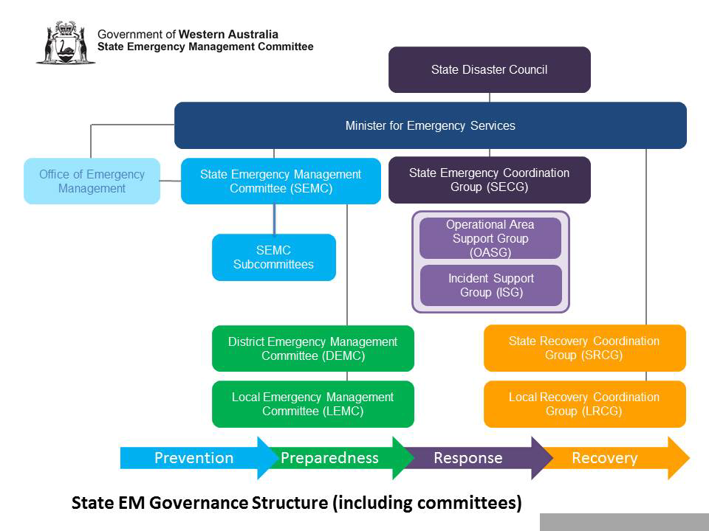
Figure 1: Emergency management governance and arrangements working together.

2.1.1 LEMC Functions
Functions of the COP LEMC are conducted in accordance with sections 39 and 40 of the EM Act and include:
- To advise and assist the LG in ensuring that local EM arrangements are established for its district;
- To liaise with public authorities and other persons in the development, review and testing of local EM arrangements;
- To carry out other EM activities as directed by the SEMC; and
- Each financial year, prepare and submit to the DEMC an annual report of activities undertaken by it during the year.

The LEMC ensures the COP is adequately planned and prepared to support the relevant Hazard Management, Controlling and Combat Agencies’ in their response to an emergency within COP LG boundary. The relationships between coordination and planning is depicted in Figure 2 below.
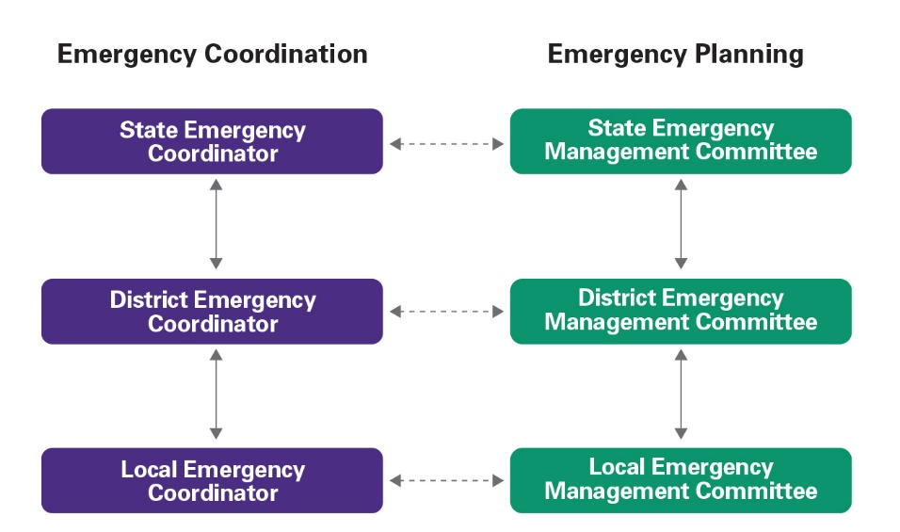

Figure 2: Relationship between emergency coordination and emergency planning.

The COP recognises the impact that the City of Perth Act 2016 has on its role and responsibility including its support to the greater Perth area in their recovery efforts.

2.1.2 Chairperson and Deputy
The nominated Chair of the LEMC is the COP, General Manager Community Development Alliance.

The Deputy Chair is shared between the WAPOL representative from Perth and Wembley, which is the Inspector Officer in Charge Perth Police Station and the Senior Sergeant, Officer in Charge Wembley Police Station.

2.1.3 Executive Officer
The nominated Executive Officer of the LEMC is the COP, Manager Community Safety and Amenity.

2.1.4 Committee Membership
The COP LEMC membership details including contact details for are located on eMERGE.

2.1.5 LEMC Member Roles and Responsibilities
Details of the LEMC member key roles and responsibilities are outlined in Appendix 1.

2.1.6 Meeting Schedule
The LEMC hosts quarterly meetings in accordance with LEMC membership, roles and responsibilities and meetings are established in State Emergency Management Plan 4.3, Preparedness Procedure 7.

Unless otherwise advised, the meetings are scheduled each quarter during the months of January, April, July and October.

2.1.7 Meeting Procedures and Agenda
The conduct of a LEMC meeting should follow State Emergency Management Preparedness Procedure 7.

The COP LEMC meetings are conducted around a set agenda which includes:

January |  | April
Contact details |  | Contact details
Post-incident reports |  | Post-incident reports
Post-exercise reports |  | Post-exercise reports
Emergency Risk Management progress |  | Emergency Risk Management progress
Treatment strategies progress |  | Treatment strategies progress
Local emergency management arrangements |  | Local emergency management arrangements
Exercise schedule |  | Exercise schedule
Commence annual Business Plan |  | Finalise and approve LEMC Annual Report & Business Plan
Agency presentation |  | Agency presentation
Major special events |  | Major special events
Other matters |  | Annual report
 |  | Other matters
July |  | October
Contact details |  | Contact details
Post-incident reports |  | Post-incident reports
Post-exercise reports |  | Post-exercise reports
Emergency Risk Management progress |  | Emergency Risk Management progress
Treatment strategies progress |  | Treatment strategies progress
Local emergency management arrangements |  | Local emergency management arrangements
Exercise schedule |  | Exercise schedule
Funding applications |  | Funding nominations
Agency presentation |  | Agency presentation
Major special events |  | Major special events
Other matters |  | Other matters

2.2 Emergency Risk Management

Commenced in 2017, the COP completed an Emergency Risk Management study in accordance with risk management standard AS/NZS 31000:2009 Risk Management. This study was used to develop the City of Perth Emergency Risk Management Plan. The plan includes identified critical COP infrastructure. When finalised, the developed City of Perth Emergency Risk Management Plan is to be located on the eMERGE portal.

In the interim, consultation was conducted with key LEMC members to provide information on the identified hazards. The hazards outlined below, will be used in the risk assessment process to be identified, analysed and evaluated and the most significant risks identified for the Perth CBD and surrounds will be recommended for priority treatment action.

2.2.1 Identified Hazards

Hazards | Risks Identified  Mitigation Strategies
Earthquake | Emergency Risk Management Plan 2019
Fire | Emergency Risk Management Plan 2019
Flood | Emergency Risk Management Plan 2019
Storm | Emergency Risk Management Plan 2019
Human epidemic | Emergency Risk Management Plan 2019
Terrorism
Air crash
Collapse
Hazardous material
Heatwave
Energy Supply Disruption
Landslide
Marine transport emergency
Nuclear powered war ship
Rail crash
Road crash
Space debris

The City also recognises there is potential for a mass casualty event caused by an opportunistic person or persons that have not been listed above.

Part 3 Response

3.1 Coordination of Emergency Operations
HMA’s, CA’s and Combat Agencies may require LG resources and assistance in an emergency. The COP is committed to provide assistance and support if available.

The key positions, functions and considerations during emergency operations are listed for the COP.

3.1.1 Local Emergency Coordinator (LEC)
The Officer in Charge at the Perth Police Station is the appointed LEC for the COP LG district.

The LEC is responsible for:
- Providing advice and support to the LEMC to develop and maintain EM arrangements for the LG district, as described in the State Emergency Management Policy Section 2.5; and
- Assist the HMA in the provision of a coordinated response at the local-level, as described in the State Emergency Management Plan Section 5.2.2.

3.1.2 Incident Support Group (ISG)
The ISG is formed by the HMA / CA appointed Incident Controller to assist with coordination, services and information during an emergency.

The role of the ISG is to provide support to the Incident Management Team (IMT) located near the emergency. The ISG is a group of people represented by the different agencies, including LG who may be involved in the emergency.

3.1.2.1 Triggers for a ISG
The triggers for an ISG are defined in State Emergency Management Policy 5.2.2 and State Emergency Management Plan Section 5.1. These are:
- Where an incident is designated as Level 2 or higher (by a HMA or CA; and/or
- Multiple agencies need to be coordinated.

3.1.2.2 Membership of a ISG
The membership of the ISG is determined by the HMA or CA. EM Agencies may be called on to be liaison officers in the ISG.

The LRC (see 4.2 Local Recovery Coordinator) should be a member of the ISG from the onset, to ensure consistency of information and a smooth cessation of response to recovery for the COP.

COP staff members co-opted to be members of the ISG must ensure they have the authority to commit resources and direct activities or tasks on behalf of the COP.

3.1.2.3 Location of the ISG
The ISG meets during the emergency and provides a focal point for a coordinated approach.

The COP can provide a meeting point for the ISG, where the ECC and alternate for the COP can be found in Part 3.1.3 Emergency Coordination Centre.

3.1.3 Emergency Coordination Centre (ECC)
The COP advises suitable locations for conduct of meetings for the ISG and the COP ECC.

Where the venue is found to be unsuitable at the time for a reason, the LEC in conjunction with the COP may move to the alternate locations.

Primary Emergency Coordination Centre
City of Perth | CityWatch | Contact Ph: 9461 6615
Secondary Emergency Coordination Centre
City of Perth | Lower Ground, Council House  27 St Georges Tce Perth | Contact Ph: 9461 3333
Alternate Emergency Coordination Centre
Perth Police Station | 2 Fitzgerald St Northbridge | Contact Ph: 9422 7111

3.1.4 CityWatch
The COP has a purpose-built surveillance centre that monitors the closed-circuit television (CCTV) network 24/7 and is one of the first to be notified of incidents and after hours oversees activities requiring immediate response. CityWatch can assist with real time information about incidents and emergencies. It also has portable CCTV towers, which may be used by the COP and HMA in an emergency.

To access CityWatch and the CCTV towers please contact 9461 6611.

3.2 Media Management and Public Information
Communities threatened or impacted by an emergency require urgent, accurate and timely information.

The provision of public information and media management is the responsibility of the HMA. All media releases are to be coordinated through the HMA.

3.2.1 City of Perth Spokesperson
The HMA may require a spokesperson from the COP to assist with public information. Once the recovery phase of the emergency has commenced the COP spokesperson will be utilised.
The COP spokesperson is the Lord Mayor or the Chief Executive Officer. This responsibility may be delegated by either of these positions.

3.2.2 COP Communications
The COP communications team and its arrangements will be enacted for the duration of recovery by the Manager Corporate Communications.

3.3 Evacuation
Communities threatened or impacted by an emergency may require relocating from their homes, workplace or accommodation. Evacuation is the responsibility of the HMA and should occur in a timely, safe and coordinated way.

To ensure the community is kept safe, LG’s support the HMA in the evacuation of community members by providing advice, support and local facilities.

3.3.1 Evacuation Management
The responsibility for managing the evacuation of a community in an emergency rests with the HMA or the CA in collaboration with the COP.

During evacuation, the HMA must consult with the DC who are responsible for welfare management in conjunction with the LG. The COP will provide support to the HMA and DC in the evacuation process.

3.3.2 Evacuation Planning
Careful consideration is required for the mass evacuation of large numbers of residential or visiting community members. Perth CBD Major Emergency Management Arrangements - Management of People Plan has been developed and is available on the eMERGE portal.

3.4 Welfare
The DC is responsible for providing welfare support services to people affected by an emergency in Western Australia. DC works in conjunction with the HMA or CA and the LG to provide support to the community during an emergency.

The DC is responsible for the welfare centres that are opened to accommodate displaced persons during an emergency. As part of this service they also provide services which may include:
- Registration and inquiry;
- Personal support;
- Food;
- Clothing and personal items; and
- Financial assistance including personal hardship and distress relief payments.

3.4.1 Welfare Management
DC will be responsible for approving the activation or opening of a welfare centre.

In support, the COP may appoint a Welfare Liaison Officer to assist with the coordination and management of facilities. Most facilities identified will be privately owned and a Memorandum of Understanding (MOU) has been sought with each of these providers and will be available on eMERGE.

Please refer to the CPFS (4) Local Welfare Plan (Restricted) on eMERGE for more details.

3.4.2 Welfare Centres
The following facilities have been identified for the City of Perth:

Facility | Address | Capacity
Gloucester Park | Nelson Cres, East Perth | 10,000
Perth Concert Hall | 5 St Georges Tce, Perth | 1,000
Perth Town Hall | Cnr Hay & Barrack St, Perth | 400
University of WA – Multiple venues | Stirling Hwy, Nedlands
Perth Convention & Exhibition Centre (PCEC) | 21 Mounts Bay Rd, Perth | 10,000
Perth Arena | Wellington St, Perth | ~ 5,000

Memorandums of Understanding have been negotiated with the Perth Concert Hall, University of WA and Gloucester Park. For more details please refer to Local Welfare Plan (Restricted).

3.4.3 Animal Welfare Plan
The Animal Welfare Plan is available on eMERGE.

3.5 Business Continuity
The COP has Business Continuity Plans (BCP) to ensure it continues to function while an emergency is occurring and during recovery. The Business Continuity Plans are supported by the Critical Incident Management Team (CIMT) and Crisis Management Team (CMT).

To assist the COP maintain a level of service to the community, two teams and supporting plans have been developed to assist with business continuity.

3.5.1 Critical Incident Management Team (CIMT)
The CIMT will be responsible for implementing all operational actions required to manage the crisis. Responsible managers and staff from across the COP are required to understand and be prepared to enact the CICT plan in accordance with directions given at the time of an incident.

3.5.2 Crisis Management Team (CMT)
The CMT provides leadership and strategic oversight and response to any crisis impacting the COP. The Crisis Management Plan (CMP) sets out the actions and principles to be followed by the CMT should any incident cause, or threaten to cause, serious impact to the COP and its community. A crisis may result from a multitude of different internal and external events including natural and manmade hazards.
Copies of Business Continuity and team plans are available on the eMERGE portal.

Part 4 Recovery
The COP must lead, manage and coordinate community recovery at the local level under section 41(4) of the Emergency Management Act 2005 and undertake these responsibilities in close cooperation with or directly supported by State government departments, supporting agencies and organisations.

4.1 Local Recovery Plan
To assist with the recovery, process a LG must have steps in place to outline the way in which they will manage recovery internally and with the community. The best way to do this is through a local recovery plan.

A local recovery plan including the nomination of a LRC is required under section 41(4) of the EM Act. A copy of the City of Perth Local Recovery Plan can be found at www.cityofperth.wa.gov.au

4.2 Local Recovery Coordinator (LRC)
Under section 41(4) of the EM Act, LG are required to include the nomination of an LRC in their local recovery plan. There should be more than one person appointed and trained to undertake the role in case the primary appointee is unavailable when the emergency occurs.

The LRC coordinates local-level recovery activities in conjunction with the LRCG, if formed and in accordance with the plans, strategies and policies it determines.

The nominated LRC for the COP is the General Manager Community Development Alliance
and General Manager Planning & Economic Development as alternate. Support for the local recovery Coordination will be provided by Community Safety & Amenity, Community Services, Operations, Parking Services and other COP business units as required

4.3 Local Recovery Coordination Group (LRCG)
A LRCG is the strategic decision-making body for recovery. The LRCG provide visible and strong leadership and have a key role in restoring confidence to the community. The LRCG is chaired by the LRC.

When considered appropriate for community recovery, the COP will determine the establishment of a LRCG. When formed, the LRCG coordinates local level recovery activities in accordance with COP plans, strategies and policies.

Details of the LRCG executive and sub-committee structure can be found in the COP Local Recovery Plan.

Appendix 1

LEMC Member Roles and Responsibilities

LEMC member role | Responsibilities
LEMC Chair | Provide leadership and support to the LEMC to ensure effective meetings and high levels of emergency management planning and preparedness for the City of Perth is undertaken.
LEMC Executive Officer | Provide executive and secretariat support to the LEMC by ensuring meetings have:  - Meeting agenda;  - Minutes and action lists;  - Correspondence; and  - Committee membership contact register;  Coordinate the development and submission of committee documents in accordance with legislative and policy requirements including;  - Annual Report;  - Annual Business Plan; and  - Local Emergency Management Arrangements.  Facilitate the provision of relevant emergency management advice to the Chair and committee as required; and  Participate as a member of sub-committees and working groups as required.
Deputy Chair/Local Emergency Coordinator | - Provide advice and support to the Local Emergency Management Committee (LEMC) to develop and maintain emergency management arrangements for the Local Government district, as described in the State Emergency Management Policy Section 2.5;  - Assist the Hazard Management Agency (HMA) in the provision of a coordinated response at the local-level, as described in the State Emergency Management Plan Section 5.2.2; and  - Carry out other emergency management activities in accordance with directions of the SEC.
Local Recovery Coordinator | - There should be more than one person appointed and trained to undertake the role in case the primary appointee is unavailable when the emergency occurs.  - The Local Recovery Coordinator is responsible for the development and implementation of recovery management arrangements, in conjunction with the Local Government including preparation, maintenance and testing of the Local Recovery Plan; and coordination of the promotion of community awareness of the recovery arrangements.
Local Welfare Coordinator (Department of Communities) | - The Department of Communities appoints the Local Welfare Coordinator.  - The Local Welfare Coordinator supports the City of Perth to determine local welfare centres in consultation with Local Government and endorsed by the Local Emergency Management Committee (LEMC).  - The Local Welfare Coordinators must also maintain and include lists of retail outlets agreeing to partnering arrangements for emergency clothing and prerequisites in local welfare plans and ensure that procedures are in place to access these services.
DFES District Emergency Management Officer | - Build emergency management resilience and capability among the public, private and not-for-profit sectors.  - Assist in the development and maintenance of effective planning and preparedness strategies across the district by the provision of quality emergency management advice and support.  - Provides strategic advice to stakeholders at district and (where required) local level, on the development and coordination of emergency management policy and planning with a focus on continuous improvement.
Kings Park and Botanic Gardens | As per incident relevant State Hazard Plan
Department of Fire and Emergency Services (DFES) | As per above.
Public Transport Authority (PTA) | As per above.
Royal Perth Hospital | As per above.
Sir Charles Gardner Hospital | As per above.
Water Corporation | As per above.
Main Roads | As per above.
ATCO Gas | As per above.
Western Power | As per above.
Development WA (DWA) | As per above.
University of Western Australia (UWA) | As per above.
City of Vincent | Observers
City of Subiaco | Observers
Town of Cambridge | Observers
City of South Perth | Observers
City of Nedlands | Observers

